HW04 REPORT

In this homework, I implemented three nonparametric regression algorithms in R which are regressogram, running mean smoother and kernel smoother respectively.

As a first step, I divided the data set into two parts by assigning first 150 data points to the training set and remaining 122 data points to the test set. Also, I separated eruption vector and waiting vector for both training and test data set. I set the bin width to 0.37 and origin parameter to 1.5. I defined data interval as a sequence between minimum value (origin parameter) and maximum value of x_train increasing 0.001. I defined left and right borders using minimum value, maximum value and bin width.

After reading chapter 8.8 from the textbook and reviewing lab06 code, first, I implemented regressogram using the formula from textbook.

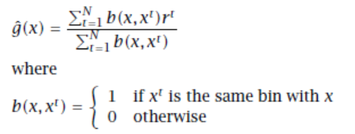

I plot the graph that shows training data points, test data points and regressogram in the same figure.

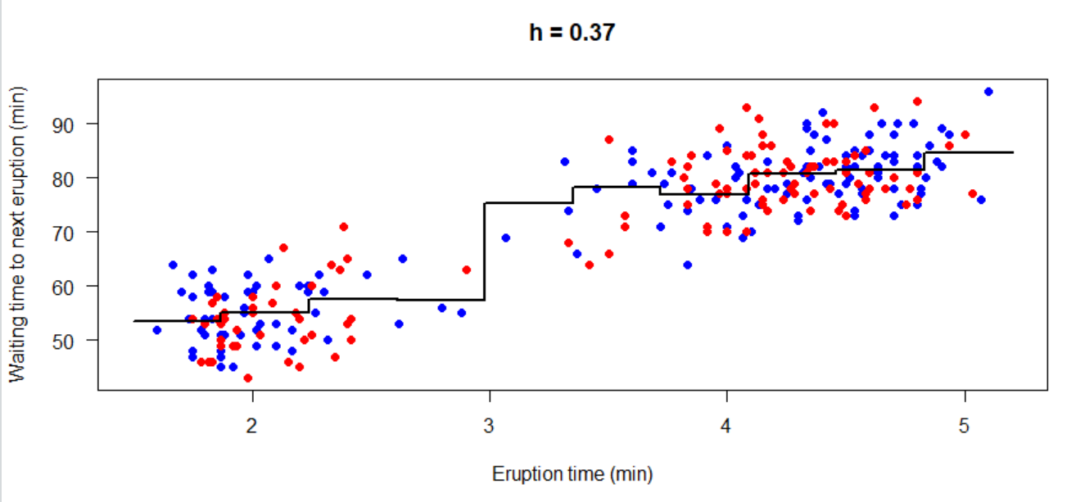

Then, I calculated the root mean square error (RMSE) implementing the below formula after finding predicted y values. I found RMSE 5.962617.

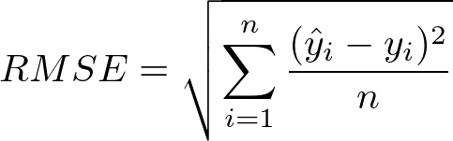

After implementing regressogram, I implemented running mean algorithm using below formula from textbook. The only difference in my implementation is, instead of 1, I used 0.5 since we used this version in the lab, and, it gives the correct output.

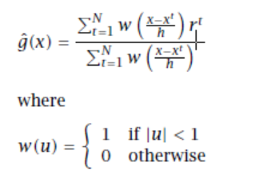

After implementation, I plot the graph that shows training data points, test data points and running mean smoother in the same figure.

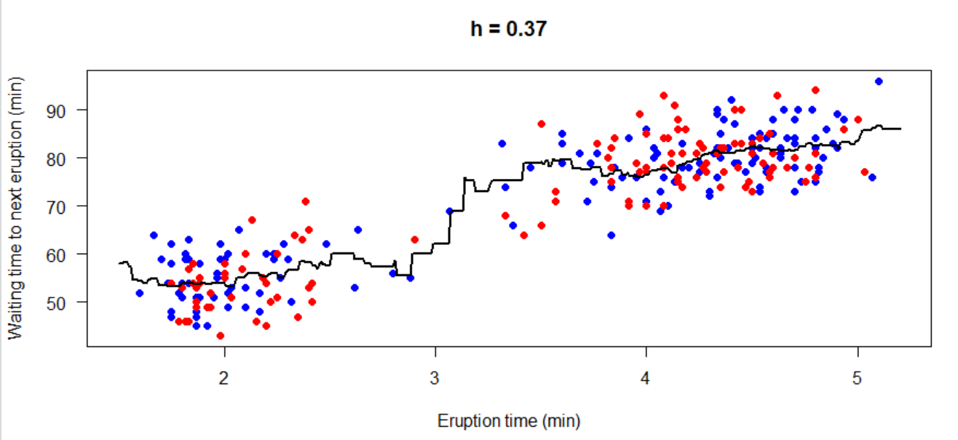

After calculating y predicted values, using the same RSME formula, I calculated RSME and found it 6.089003 for running mean smoother.

As a final step, I implemented kernel smoother algorithm using gaussian kernel formula in it.

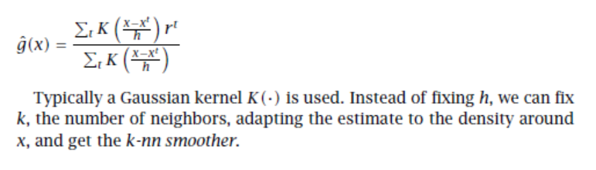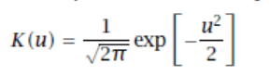

(Gaussian Kernel)

After implementation, I plot the graph that shows training data points, test data points and kernel smoother in the same figure.

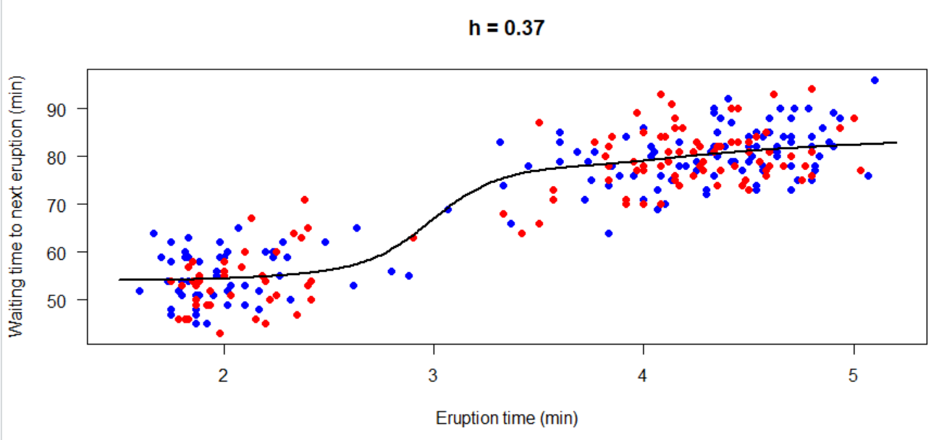

After calculating y predicted values, using the same RSME formula, I calculated RSME and found it 5.874362 for kernel smoother.